**SELIG Matthieu PROMO 45  
2AG1**

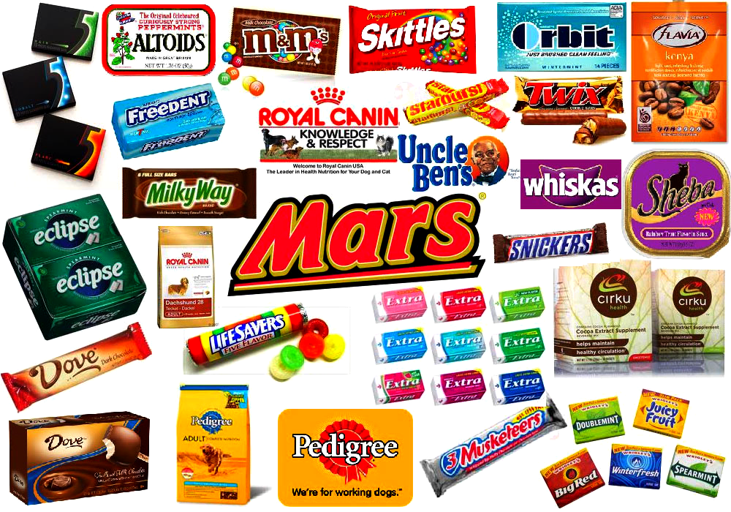**MARS INCORPORATED AND ITS PRODUCTS**

**Friday, 28th February 2014 For Mrs Knight**

**Table of contents**

I. INTRODUCTION 3

II. PRESENTATION OF THE COMPANY 3  
1) History……………..………………………………………………………………..…3  
2) Current situation and figures.....……………………………………………4

III. ITS DIFFERENT KEY FOOD PRODUCTS 9  
1) Mars Chocolate………………………………………………………..…..…...…9  
 a) Mars (chocolate bar)……………………………………….…………..………..10  
 b) M&M'S…………………………………………………………………….…………….11  
2) Mars Wrigley…………………………………………………..………..………..13  
3) Mars Petcare………………………………………………..…..………………..17  
4) Mars Food, Drinks and Symbosciences…………….…………………19

IV. CONCLUSION 20

Bibliography………………………………………………………………………..………….21

# INTRODUCTION

Mars Incorporated is a current American food processing industry whose headquarters are found in McLean, Virginia, United States. It is the third-largest private company in the U.S. as far Forbes, entirely owned by the Mars family, and serves its products all around the world and had revenue of 30 billion US dollars the last year. It creates and distributes in 6 key food segments namely Chocolate, Food, Drinks, Wrigley, Petcare and Symboscience, all of them produced in different locations. Employing 70,000 people in 2008, Mars incorporation still remains today one of the main industries of food distribution in the world by its quality and its renown.

This report is divided in two main parts, the first one deals with the global presentation of the company, and the second one talks about the different products proposed and generated by the company.

# PRESENTATION OF THE COMPANY

1. **History**

The company was founded in 1911 by Frank C. Mars and his wife Ethel V. Mars in Tacoma, Washington, US. In the beginning the factory was supposed to produce and sell fresh candy wholesale, but it was unsuccessful and the business failed. In 1920, Frank went to Minnesota and created the first incarnation of the present day Mars which was named Mar-O-Bar Co and became later incorporated in the same place as its current title: Mars Incorporated.  In 1923, Frank's son, Forrest, introduced the Milky Way bar because he had been inspired by a popular type of milkshake. His advertising slogan was "chocolate Malted Milk in a candy bar", and it became the best-selling candy bar during the period. In 1929, Frank delocalized the company to Chicago, [Illinois](http://en.wikipedia.org/wiki/Illinois) and started a huge production of its son's bar. Nevertheless, the first Mars bar launch started in 1932 in the United Kingdom, there, Forrest (his son) and him dreamt to build a business based on the "mutuality of benefits" (Forrest E. Mars, Sr.) for the stakeholders, and the company has tried to keep this idea in force until today. Afterwards, they chose to enter the pet care arena in 1935, and then in 1940 they created the m&m's business in the US, and developed the food business in 1943. It is in those days that Forrest decided to install the headquarters of his diversified company in Washington, D.C. because food manufacturers finally became larger than his father's original confectionery business. They decided to merge their respective business in 1967 whereupon Forrest acquired his father's business before 1970, whose headquarters were in Chicago until this date. From there, high-tech vending machines began to be developed by Mars Electronics International and lots of others innovations. He retired and let the post of co-presidents to the elder Mars children. After this legacy, Mars entered frozen snack business (Dove international for example) and developed many new candies and pet food brands between 1986 and 1991. It has been reported that Mars Incorporated had facilities in about 65 countries and sold its products in more than 140 since the beginning of the 2000's.

1. **Current situation and figures**

First of all, the current key people in Mars Incorporated are the following:

* Steven Badger (Chairman),
* Mr. Paul S. Michaels (President and CEO),
* Mr Reuben Gamoran (Chief Financial Officer and Vice President),
* Mr David Kamenetzky (Vice President, Corporate Affairs and Strategic Initiatives)
* Mr. John Donofrio (Vice President, Secretary and General Counsel)
* Mr. Richard Ware (Vice President, Supply, Research and Development and Procurement)
* Mr. Todd R. Lachman (President of Petcare Business),
* Mr. Grand Reid (President of Chocolate Business),
* Mr. Martin Radvan (President of Wrigley Business)

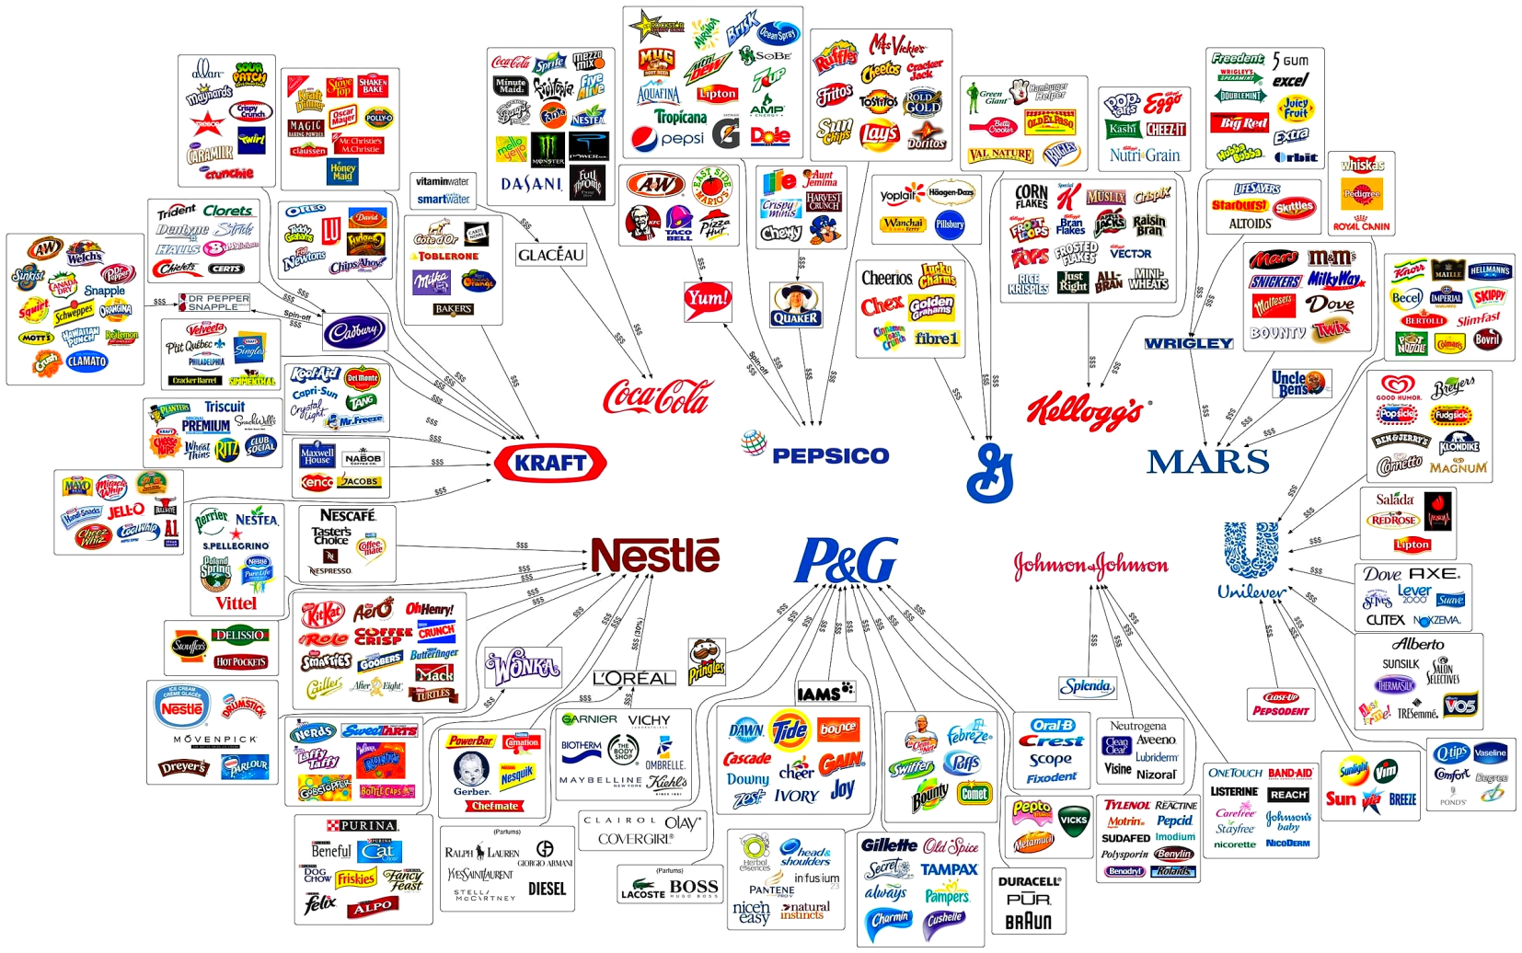On the diagram below, several brands of the main companies (Kellogs, Nestlé, P&G, Kraft, Coca Cola, Pepsico or Johnson & Johnson) in the world are shown. This is only a summary, all the brands are not visible on the diagram but the most significant are present. The key food segments are clearly observables for Mars Incorporated, with among others Mars, M&M, Snickers, Dove or Twix for Mars Chocolate, Uncle Ben's for Mars Food, Five, Freedent or Orbit for Mars Wrigley, and Pedigree, Royal Canin or even Whiskas for Mars Petcare.

Diagram 1 : Belonging of different brands by big companies

|  |
| --- |
|  |

As previously stated, the current economic situation of the company is relatively good, because its turnover does not decrease, and it recruits hundreds of employees worldwide each year (about 2,000 between 2012 and 2014). Its stable economic situation and its business gives Mars Incorporated a place in the very small circle of the 100 best companies to work for, ahead from McDonald's (MCD), Starbucks (SBUX) or General Mills (GIS). The Franck's company namely owes its success to the strong involvement of its staff, which is being closely monitored in order to ensure that everything works for the best. Indeed, if an employee is late, he gets docked 10% of his pay. Furthermore, Mars offers neither company-driven pensions nor stock options and their work sites are utilitarian rather than comfy. There, there are no Football tables or sushi chefs, and, as for its CEO and President "A lot of really good companies invest in the wrong architecture" (Paul S. Michaels). But, once you get the job, you stay. Some families claimed 3 generations of employees. Women represent about 40% of the managers in the whole company. There are even unusual perks, like vending machines that distribute free candies all day long (several employees are known because they eat half a pound of free M&M's per day), or the fact that chewing gum at meetings is encouraged (as long as it is Wrigley's chew-gum).

The Company has five main Principles:

* Quality : they consider that the customer is the boss and they have the necessity to do their best in all the work they do
* Responsibility : they support responsibilities of others, every associates are asked to take direct responsibility for results, to exercise initiative and to judge and make decisions as required
* Mutuality : mutual benefit is a shared benefit (which will endure), their benefits don't need to be strictly financial
* Efficiency : to use resources to the full, don't waste anything and do only what they can do best, their strength is the way to organize their products (physical, human and financial) for a maximum productivity and a high level delivered quality and the less cost as possible
* 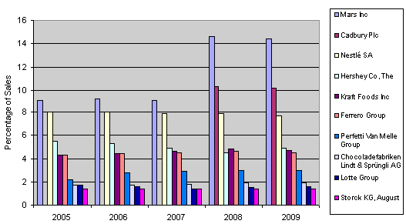Freedom : in order to shape their future, this is a family-owned corporation which didn't sell stocks or incur debts to fuel their business

Bar chart 1 : Global top 10 confectionery company shares by percentage breakdown

This bar chart shows the superiority of the company from 2005 to 2009 by outdistancing its opponents in term of sales. Nestle, Hershey or Cadbury are also behind Mars Incorporated and the gap widens with the years. They reached more than 14% in 2008 and 2009.

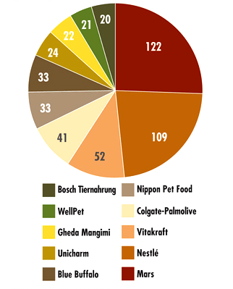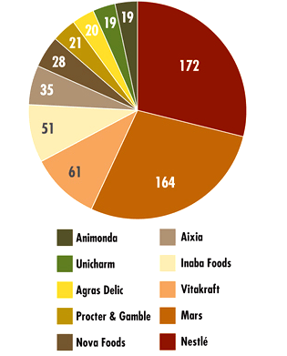

Pie chart 1 : Top 10 companies for dog food product launches in 2010

Pie chart 2 : Top 10 companies for cat food product launches in 2010

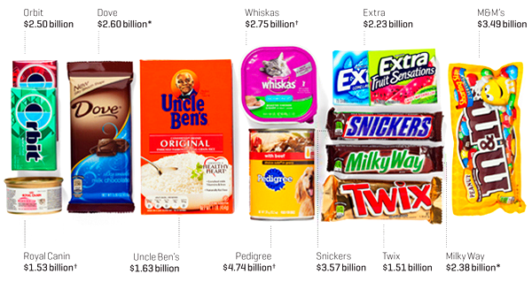These two pie charts show the domination of Mars Incorporated in the animal food market since 2010. The company competes with companies such as Nestle or Vitakraft. Plus, Mars Incorporated is now part of the top 10 paying-companies and the top 10 perks-companies.

The large number of sales and revenues of the company and the role of the Petcare products (Pedigree is the best selling product) are clearly highlighted on this picture.

Picture 1: The 11 brands with revenue of 1 billion/year or more

# ITS DIFFERENT KEY FOOD PRODUCTS

1. **Mars Chocolate**

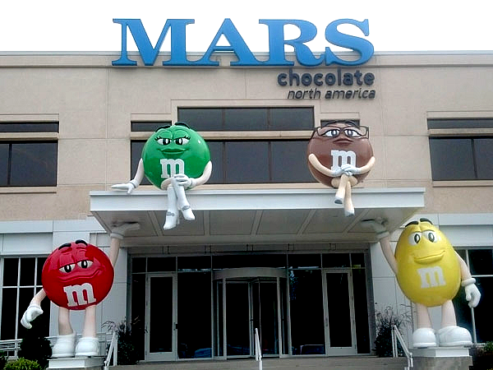The headquarters of Mars Chocolate are based in Hackettstown, Mount Olive, New Jersey, United States. This is one of the biggest chocolate manufacturers in the world and it employs about 16,500 associates in no less than 21 countries. In total twenty-nine brands with five billion-dollar brands (see Picture 1, page 8). For the others, the most famous are Bounty, Maltesers, Celebrations, Dove, Balisto or Galaxy. They were also the 1st chocolate company to source all their cocoa from certified supplies, that is why they became in 2012 the world's largest user of certified cocoa with more than 20%. Cocoa certified by Rainforest Alliance, Fair-trade and UTZ are currently bought in order to increase the sustainability of farming practices and the livelihood of farmers. They also stopped advertising and marketing straightly to children under twelve years old in order not to influence the consumption of sugary foods at an early age. It is in this place that is found the second largest candy plant, and about 500,000 square foot building with 4 huge leggy M&MS characters (red, yellow, brown, green) out front.

Picture 2 : Headquarters of Mars Chocolate, Hackettstown, New Jersey

1. **Mars (chocolate bar)**

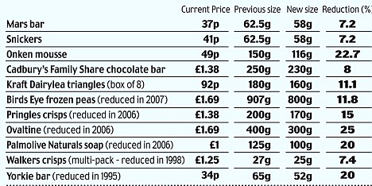The first manufactured chocolate bar was in the factory in Slough, Berkshire, United Kingdom. The bar contained caramel, nougat, both covered in milk chocolate. Over time, the basic recipe was unchanged but the main components' proportions and the size of the bar were modified. This is this version which is sold in the entire world in a black wrapper packaged with red lettering. They decided to reformulate its logo to improve it in 2002, and this led to its price increased. They smartly reduced slightly the overall weight of the bar without changing the price, so the consumer don't pay attention to the weight but he sees that the price is the same, this is a technique widely used by food companies to lure clients.  
Thus, the price is inversely proportional to the weight of the product, if the weight decreases, the price increases because the price per kilogram varies.

Even if the weight decrease is not the highest between Mars bar and other products, figures about this reduction (7. 2%) are nevertheless substantial.   
About this subject, a lot of slogans have been used to attract the curiosity and to convince people that theirs products are the best, a few examples:   
"*Earth – what you'd eat if you lived on Mars*", in New Zealand and Australia, they used humor with a pun to assimilate the chocolate bar to the planet,  
"*An almond in every bite*!", in United States, to highlight the fact that there are almond in this specific bar,  
"*A Mars a day helps you work, rest and play*", in Australia, United Kingdom, Canada, New Zealand, which indicates that if you eat that chocolate bar once a day, you will enjoy your day,  
"*Un Mars, et ça repart*" (= A Mars, and you're off again), in France, it means that if you feel bad, a mouthful of the chocolate bar will help you feel better,  
"*Pleasure you can't measure*", UK, to appeal more to women and youths.  
It is important to be aware that Mars chocolate bar in United Kingdom are not the same that the Mars chocolate bar found in United States, it depends on the place where they were fabricated (Australia, US, UK…) and so it is pretty rare to find the United Kingdom's Mars products in the United States and inversely.

Table 1 : Significant decrease in the weight of several products

1. 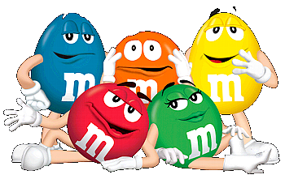**M&M'S**

It is a famous brand of chocolate candies ("colorful button-shaped candies"), created in 1941 by Forrest Mars and Bruce Murrie (the son of William Murrie, Hershey president). They altogether wanted to develop a hard shelled candy with chocolate inside. The idea came earlier from chocolate pellets eaten by soldiers in the Spanish Civil War. "M&M's" refers to Mars & Murrie. The candy is often known as "the chocolate that melts in your mouth and not in your hand" because of its composition and characteristics. There is a "m" printed on each candies to remind people the original brand. Each of the six main colors (red, blue, orange, yellow, green and brown) has an identity, however, these five colors haven't always been present since the beginning of the production. Actually, only yellow, green and brown have been present from the start, orange arrived in 1976 and 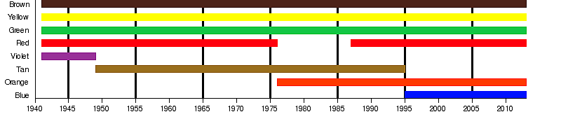blue arrived in 1995. So, there were some variations in the M&M's colors through the time, as it is shown on the graphic above.

Picture 3 : The five main colors of the M&M's characters

Graph 1 : Plenty candies colors over time

It is in Hackettstown, with about 1,200 employees, that about half of all M&M's production in the United States is made. Indeed, 190 millions M&M's are produced by employees every eight hours, in about 25 colors. The process is mainly automated, M&M's take a day to make, and half of the time spent is for the special coating process which gives the hard shell that prevents the candies to melt in the hands. About 3% are rejected because of insufficient quality. There are plenty flavors found in the United States, as pretzel, mint, and peanut butter. However, manufacturing in United Kingdom is limited to chocolate and peanut, by the way, these are the only two flavors that people can find in the M&M's World in London. Nevertheless, a big choice of diversified colors is available in this store. Each color is crafted in huge jars (picture on the next page), separated from the others and packed with the 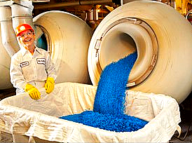others colors later. It is supposed to proceed to an equal repartition in each pack (about 20% of each color when there were 5 colors), but studies have shown that the repartition was done randomly.

Picture 4: Jar with the blue M&M's

The company proposed a lot of campaigns to highlight their products, namely one where people had to vote to choose the color of the new variety of M&M's (the winner was blue in 1995). People followed the issue on most of the television network's news programs. Moreover, the company had the opportunity to light the Empire State Building in blue (the new color) during a night, it also brought a huge wave of medias who suddenly were interested in this event, and so the people.

1. **Mars Wrigley**

The headquarters of the Wrigley Company (a subsidiary of Mars Incorporated) are found in Goose Island, Chicago, Illinois, United States until 2005. Before this date, the headquarters were located on Michigan Avenue, with its famous Wrigley Building, which still belongs to the company but is no more the headquarter. It was founded in 1891, in those days they sold products such as baking powder or soap. It is in 1892 that William Wrigley Junior first packaged chewing gum which became more popular than the baking powder. At first, Wrigley sold gum only to soldier during WWII, while Orbit was available for the public. The company currently has operations in approximately 50 countries and sells its products in about 180 countries, it brings work to many lands, with 140 factories all around the world (US, Australia, Mexico, UK, France, Spain, Canada, Czech Republic, Germany, South Africa, India, Somalia, Russia, North Korea (the only US enterprise there) and others) with a total of 17,000 employees. It possesses nearly 34 brands in total, including Extra, Orbit, Five, Skittles or Starburst, and 4 brands which are now more than a century: Life Savers, Altoids, Juicy Fruit and Wrigley's Spearmint. The company has been acquired by Mars Incorporated for approximately 23 billion US dollars in 2008, and they expect to generate sales in excess of 27 billion US dollars.

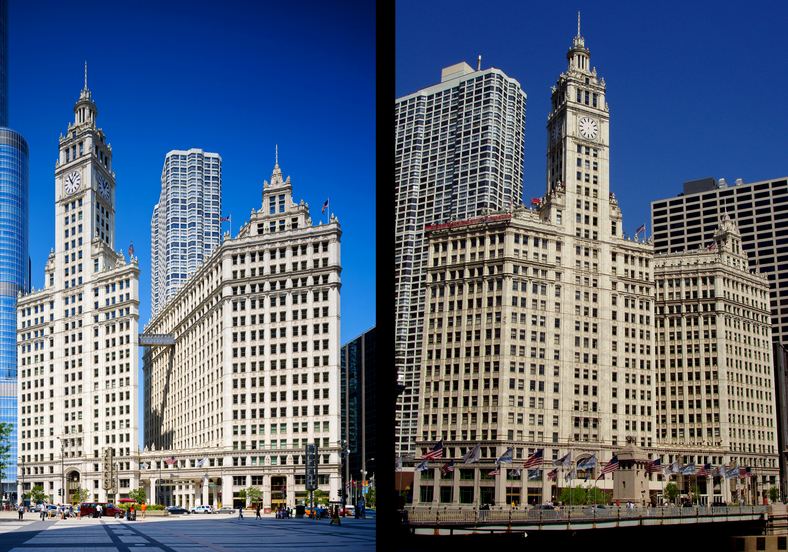In addition to this, the company has a lot of principles that they want to inform.   
First of all, principles about people:   
• the Wrigley Company Foundation has donated more than 55 million dollars to charitable organizations around the world, namely (FEE) Foundation for Environmental Education and Save the Children (this last one impacts about 280,000 children in the worldwide and helps to provide nutrition, hygiene and oral health)  
• it built twelve Hope Schools across 8 provinces in China, more than 6,500 underprivileged children benefitted of this help   
• in 2011, Associates throughout Spain collected staple food for local food banks, and they collected about 1.5 ton of food and Wrigley chose to match the weight with dental kit donations  
• they decided do not buy advertising time if more than a 1/4 of the audience is estimated under 12 years  
• Mars was the first company which used GDA (Guideline Daily Amount) labels on its confectionery products   
• Wrigley has been researching the oral health benefits of chewing gum since almost hundred years, they also partnered with academic institutions.  
It has been shown that when brushing is impossible, chewing sugar-free gum is an efficient way to help keep teeth clean and healthy, a good point and a great advertisement to the company which did not wait to talk out loud about it.

Picture 5: Side view (on the left) and front view (on the right) of the Wrigley Building on Michigan Avenue

And in a second time, principles about the planet :   
• Wrigley aims to eliminate fossil fuel energy use and greenhouse gas (GHG) emissions before 2040  
• Associates are exploring the use of renewable energy sources to power their factory operations when it has an environmental and economic sense  
•  The Wrigley Asquith team from Australia installed a new solar photovoltaic system (PV), with 610 panels, it is 125 tons of GHG emission saved annually  
• The company intend to decrease total water usage by 25% between now and 2015, and municipal water consumption by 35%  
• Nowadays, 9 factories send zero waste to landfill : Asquith in Australia, Porici in Czech Republic, Plymouth in England, Biesheim in France, Baddi and Bangalore in India, Poznan in Poland, Antipolo City in Philippines and Taipei in Taiwan  
• 850 tons of aluminum saved per year, and by replacing the aluminum loop on Slim Pack 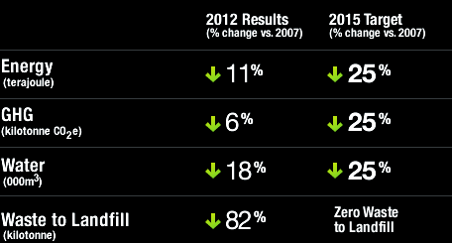that holds the sticks together with paper, 100 tons of aluminum were saved in 2011

Table 2 : Wrigley Manufacturing footprint

• 7 millions hours without lost time incident in Guanghzou, China, in 2012

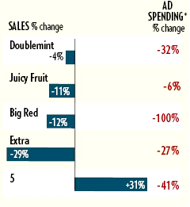On the table above, Wrigley's objectives for the next 3 years. They have already considerably reduced their energy and water consumption, GHG emission and waste to landfill during the last 5 years.

However, in the last years the company chose to cut advertising for its older brands, that is why Wrigley sales continue to decline. But most of the growth came from its new brand (Five) appeared in 2007.

Table 3 : Sales volume vs AD spending

1. **Mars Petcare**

Picture 6 : The official logo of Mars Petcare

Headquartered in Brussels, Belgium, Mars Petcare is a one of the world's leading pet care providers. 34,000 employees work for the company in 50 countries and about 199 locations in the whole world. Mars Petcare has been producing pet foods since 1935 since acquiring Chappel Brothers (only dog food at the beginning) and has never stopped growing to reach 35 brands in total including 3 billion dollar brand (Royal Canin, Whiskas and Pedigree). Lots of others big brands are possessed by Mars such as Banfield, Sheba, Frolic, Perfect Fit or Cesar. They also developed fish food, horse food (respectively Mars Fishcare and Mars Horsecare), Petservices and The Waltham Centre for Pet Nutrition since. This last one is a leading scientific authority in pet nutrition and wellbeing and advanced the borders of scientific research into pet nutrition and health for over 50 years. They mainly produce dry pet foods, soft-dry food, soft treats, and dog biscuits, and they sponsor several little organizations such as PetNet (website for the Petcare Information and Advisory Service). The creation of Pedigree Foundation in 2008 has awarded grants of about 4 million dollars to hundreds of shelters and dogs rescue groups only in the United States.

As it has been shown on the first picture, Mars Petcare owns the best selling Mars Incorporated product, which is a food that only concerns dogs: Pedigree. The company also brought support for Handi'chiens in France (trains assistance dog for people with disabilities), they provided 25 tons of Pedigree dog food (around 75,000 dollars). They created a campaign "*They're coming with us*" for Whiskas and Pedigree which helped to prevent pets from being abandoned and which gave advices to help owners take care about their 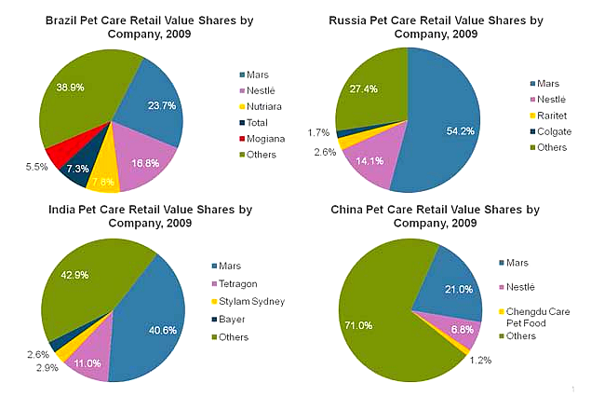animal.

Pie charts 3-4-5-6 : Pet care by competitive landscape by leading companies

These four pie charts reveal that Mars Petcare dominates the pet food market in certain countries by having the best retail value shares (in India and Russia). They have about 4 times more retail value shares than Nestle in Russia and in China.

They recently announced a voluntary recall involving 3 varieties of Pedigree food because of a potential choking risk, only cans were concerned by this announcement. This story made a lot of noise in the media and afterwards people were more suspicious to choose their products and it also brought a short decline in the purchase of these 3 products in the United States (because the deficient lot was only sent in the US).

1. **Mars Food, Drinks and Symboscience**

Mars Food headquarters are in the same place as Mars Petcare, in Brussels, Belgium. It employed more than 2,000 associates in 11 manufacturing sites in the world, with different products according to their localization. It is composed by 12 brands found in about 30 countries, the best known are Ebly and Uncle Ben's. They constantly try to improve their products quality, for example by trying to enhance the nutrient content of the food and reduce sodium levels by an average of 25% in all their products (31% for Uncle Ben's rice).

Mars Drinks employs more than 650 associates in 8 countries, its headquarters being in West Chester, Pennsylvania in US and in Basingstoke in UK. It possesses 5 brands in total: Flavia, Aletrra (coffees), The Bright Tea, Dove/Galaxy (hot chocolate drinks) and Klix. The company provides more than 1 billion drinks each year through 100,000 machines. Mars Drinks introduced 100% recyclable Freshpack in North America for the first time in 2012 (across English Breakfast and Earl Grey), but their goal is a 100% Freshpack fully recyclable by 2015. They also plan to purchase 100% of their coffee beans from certified sources for the same year.

Mars Symboscience is a global health and life science segment of Mars Incorporated, they have to develop and commercialize products which respect the health and wellbeing of people, pets and the planet. It started in 2005 in their headquarters in Germantown, Maryland, US. It also serves as an incubator for business sells. A lot of tests and research are done in this field, especially since the 2000s.

# CONCLUSION

The report has presented the general presentation of Mars Incorporated, and the details of the products sold by the company. This is also a tremendous company which employs more than 70,000 employees all around the world, it has a high economic value because of its many famous brands, and it does not cease to make profit and to grow up. This is a family-owned corporation, and employees are treated with respect and in favorable conditions. Thanks to its 6 key food segments and the awesomeness of their respective products, Mars Incorporated remains one of the world's most powerful food companies.

**Bibliography :**

http://www.ats-sea.agr.gc.ca/inter/5804-eng.htm  
http://www.chicagobusiness.com/article/20100213/ISSUE01/100033018/mars-inc-cuts-ad-spending-for-wrigley-gum-brands   
http://www.company-histories.com/Mars-Incorporated-Company-History.html  
http://en.wikipedia.org/wiki/Mars_(chocolate_bar)  
http://en.wikipedia.org/wiki/Mars,_Incorporated  
 http://www.euromonitor.com/bric-pet-care-part-1-how-will-emerging-markets-shape-the-industry-/report  
http://fr.scribd.com/doc/76390839/M-M-s-World-Branding-Report  
http://www.hoovers.com/company/information/cs/companyprofile.Mars_Petcare_US_Inc.2c8b54e965a09921.html  
http://investing.businessweek.com/research/stocks/private/snapshot.asp?privcapId=184468  
http://management.fortune.cnn.com/2013/01/17/best-companies-mars/  
http://www.marketresearch.com/MarketLine-v3883/Mars-Incorporated-Strategy-SWOT-6725935/  
http://www.mars.com/global/about.aspx  
http://www.marsgraduates.com.au/globalcompany.aspx  
http://www.myfoxatlanta.com/story/18946941/mars-petcare-recalling-dog-food#axzz2uH0nXZZA http://www.petnet.com.au/about-us  
http://www.petfoodindustry.com/Petfood_top_10__Riding_out_the_storm.html  
http://www.quora.com/Mars-Inc-1  
http://www.thewrigleybuilding.com/gallery/  
http://www.wrigley.com/global/principles-in-action/planet.aspx